**Installation and Configuration for Microsoft Dynamics AX 2012 R3 Retail in Brick and Mortar Stores**

**Module 01: Technical Overview of Brick and Mortar Stores**

**Prerequisites**

Processor: 1.1 Ghz

RAM: 4GB or higher for server & 2 GB for client

**Topology**

High Level Overview

AX core Component 🡪 Commerce Data Exchange Components 🡪 Instore Components and Online Store 🡪 Modern POS

Detail Overview

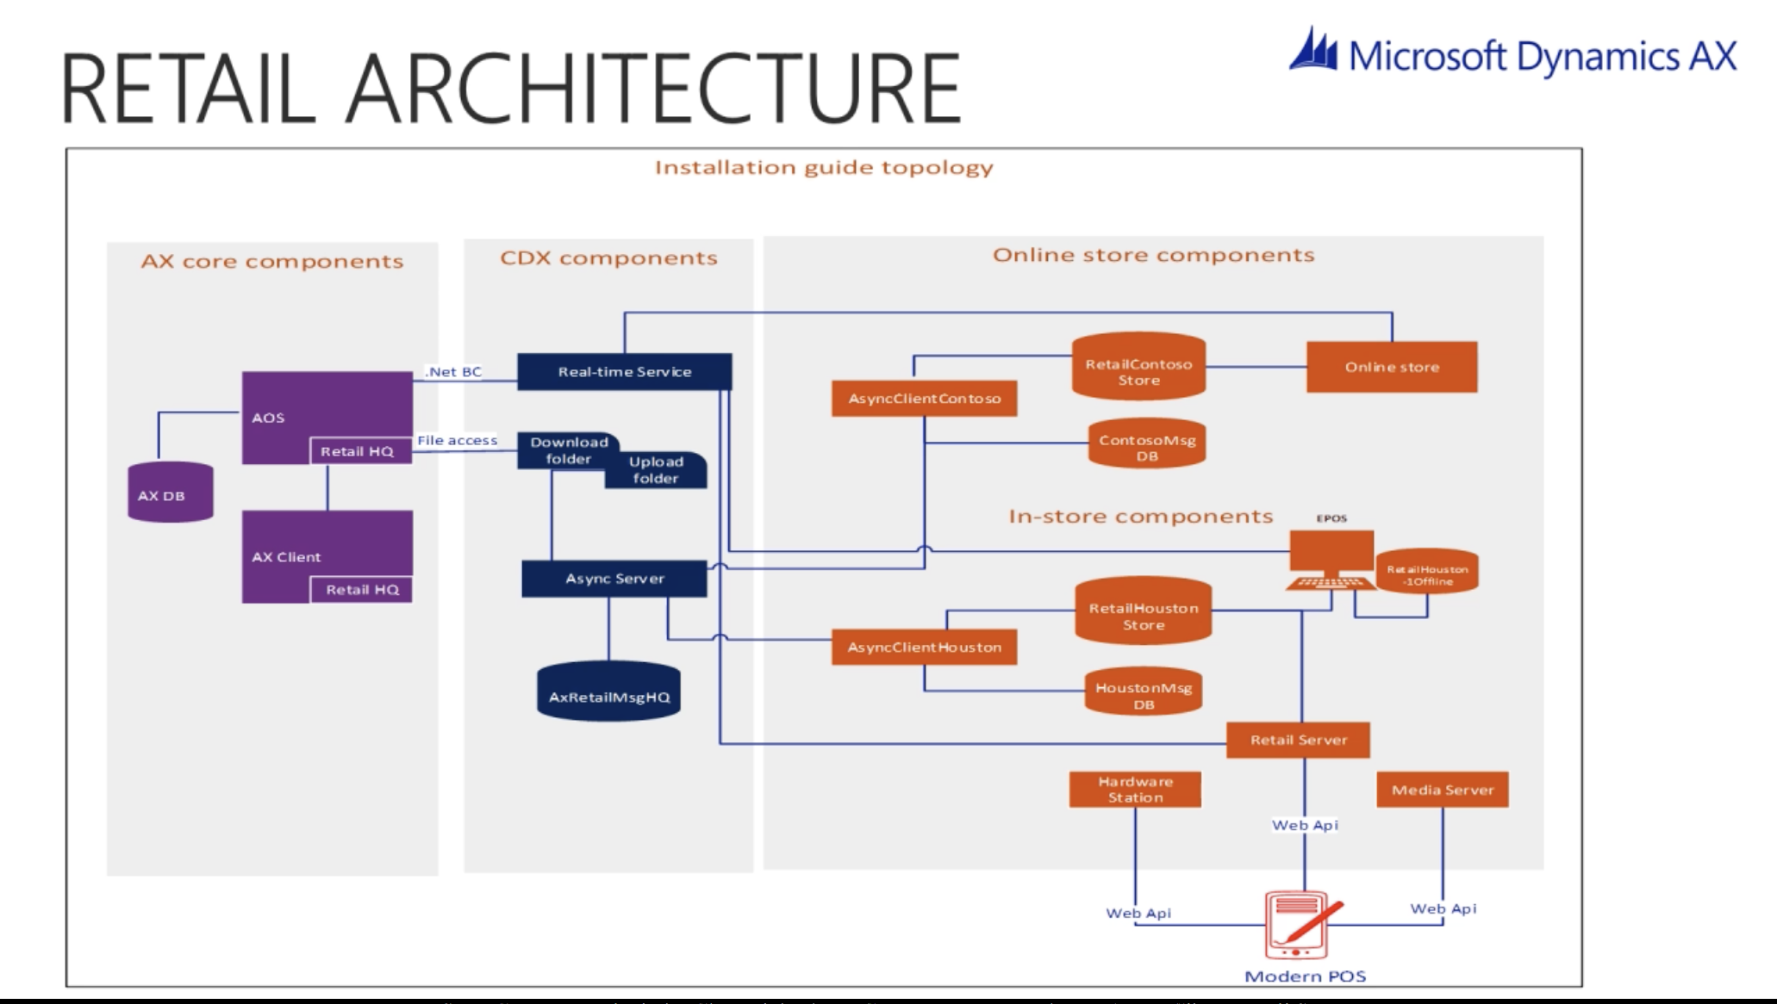

**AX Core components**

Retail Headquarters is AX 2012 core components, required runtime components and install on AOS and AX Clients

**CDX Components**

**Async server**

Provide data exchange between AX channels like POS, Commerce Run time and Retail server

**Real Time Service**

Provide access to AX data at real time

**In-store Components**

**Channel Database**

Single database schema for POS, Modren POS and onine store. One channel database have data for one or many stores.

**Retail Server**

This enable retailer and consumer to access information and perform using any device, anytime from anywhere.

**CXX Async Client**

This Async Client replication data between AX and channel database.

**POS**

Process transaction

**Modern POS**

Same is POS but with little more function.

**Hardware Station**

Allow peripherals to be shared for modern POS like printer, cash drawer, pin pad . it support OPOS and windows devices.

**Typical Deployment**

**Head Office deployment**

**Database server** to host AX database

**AX AOS** (Application Object Server)

**Communication server** to host real time service and Async Server

**Client Computer** to run AX Client

**Store Deployment**

**Database server** to host channel database, Async Client and retail server

**Register computer** to host POS and offline database as well as Modren POS

**Hardware Station computer** connected with devices to host Retail hardware station

**Mobile Devices** running mobile POS